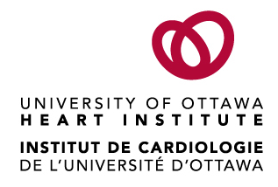 | 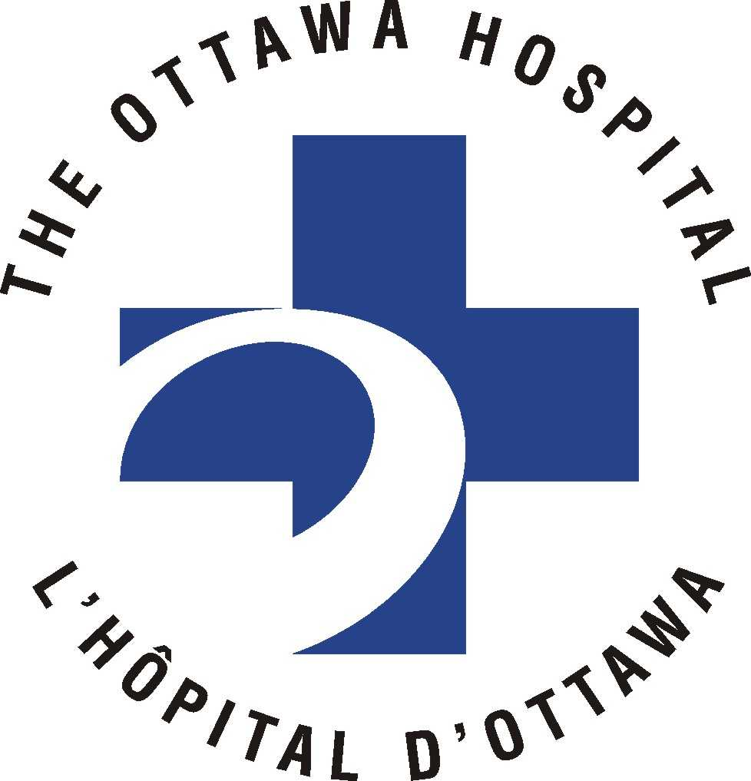
Ottawa Hospital Research Ethics Boards / Conseils d’éthique en recherches

Civic Box 411 725 Parkdale Avenue, Ottawa, Ontario K1Y 4E9 613-798-5555 ext. 14902 Fax : 613-761-4311
http://www.ohri.ca/ohreb

ADVERSE EVENT REPORT
Adverse Events must be summarized on this control sheet. MEDWATCH or CIOMS reports should also be attached.

OHREB Protocol Number:
Protocol Title:
Principal Investigator at the Ottawa Hospital:
Therapeutic Product name:
Date of this Report:
Number of Adverse Events Included in this Report:

ID | Type | Location | Is it drug related? | Event  Describe the event as concisely as possible and check app. boxes |  |  |  | Are changes required to:
 |  |  |  |  | *DSMBRev? | Serious | Unexpected | Protocol | Informed consent
SAE #:  Date: | New  F/U  # | Local External | Yes  No  Possibly
SAE #:  Date: | New  F/U  # | Local External | Yes  No  Possibly
SAE #:  Date: | New  F/U  # | Local External | Yes  No  Possibly
SAE #: Date: | New  F/U  # | Local External | Yes  No  Possibly
SAE #:  Date: | New  F/U  # | Local External | Yes  No  Possibly
SAE #:  Date: | New  F/U  # | Local External | Yes  No  Possibly
SAE #:  Date: | New  F/U  # | Local External | Yes  No  Possibly
SAE #:  Date: | New  F/U  # | Local External | Yes  No  Possibly
SAE #: Date: | New  F/U  # | Local External | Yes  No  Possibly
SAE #:  Date: | New  F/U  # | Local External | Yes  No  Possibly
SAE #:  Date: | New  F/U  # | Local External | Yes  No  Possibly
SAE #:  Date: | New  F/U  # | Local External | Yes  No  Possibly
SAE #:  Date: | New  F/U  # | Local External | Yes  No  Possibly
SAE #:  Date: | New  F/U  # | Local External | Yes  No  Possibly
SAE #:  Date: | New  F/U  # | Local External | Yes  No  Possibly
SAE #:  Date: | New  F/U  # | Local External | Yes  No  Possibly
SAE #:  Date: | New  F/U  # | Local External | Yes  No  Possibly
SAE #:  Date: | New  F/U  # | Local External | Yes  No  Possibly

* DSMB = Data Safety Monitoring Board

Signature of Principal Investigator Date

PLEASE FORWARD TO: Ottawa Hospital Research Ethics Board, 725 Parkdale Avenue, Civic Box 411, LOEB Building, Ottawa, ON K1Y 4E9

